**Name: ………………………………………………………………………Stream………………………………………………………………**

**M.T ST HENRY'S HIGH SCHOOL MUKONOEND OF TERM111 COMPETENCE BASED ASSESSMENT-2023**

**S.1CHEMISTRYTIME: 2HOURS 15MINUTES**

**INSTRUCTIONS**

1. **Answer all questions in this paper.**
2. **Write answers on the answer sheets provided.**
3. **Symbols must be written correctly.**

**QUESTION 1**

**Plastic waste management is a challenge in our communities today. Poor disposal of plastics as shown in picture below is a big threat to human health around globe. Waste management is important because it takes advantages of science to deal with our daily waste.**

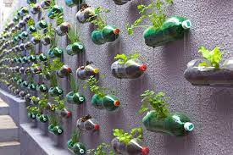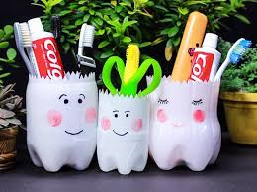

**TASK: Using the knowledge acquired on temporary and permanent changes ,explain to your community the threats and possible solutions to the threats posed to the man and environment as a way of managing waste in the environment.(20marks)**

**QUESTION 2**

**You have been appointed as the laboratory technician at your school and you have been given to supervise these students while carrying out a chemistry experiment. At a blink of an eye, you realise students in two groups are behaving as shown in the pictures below .**

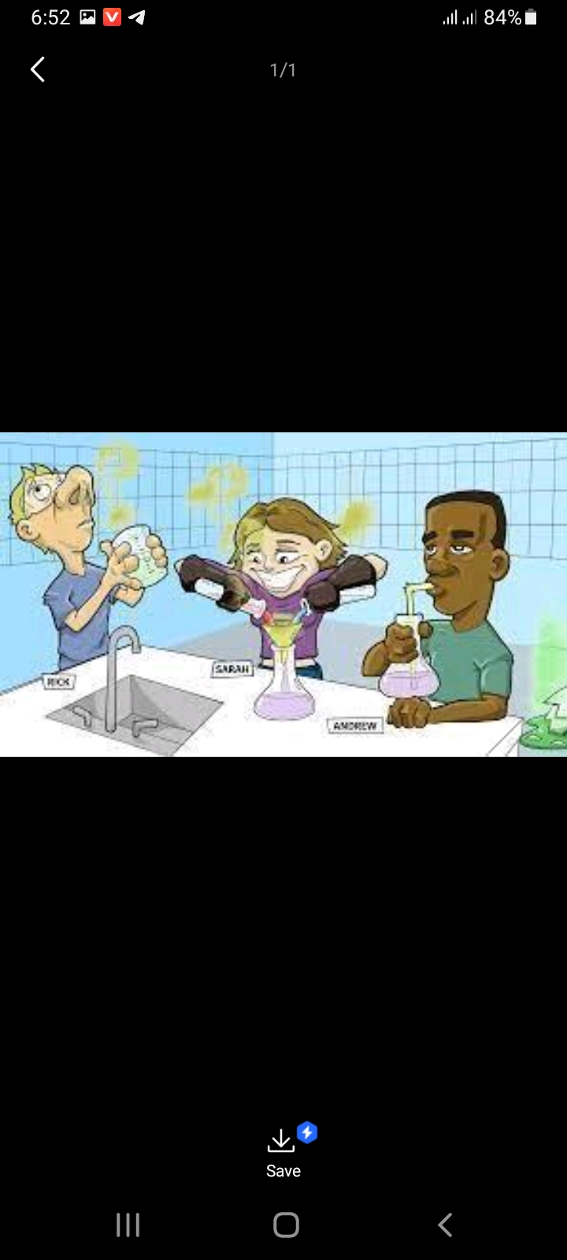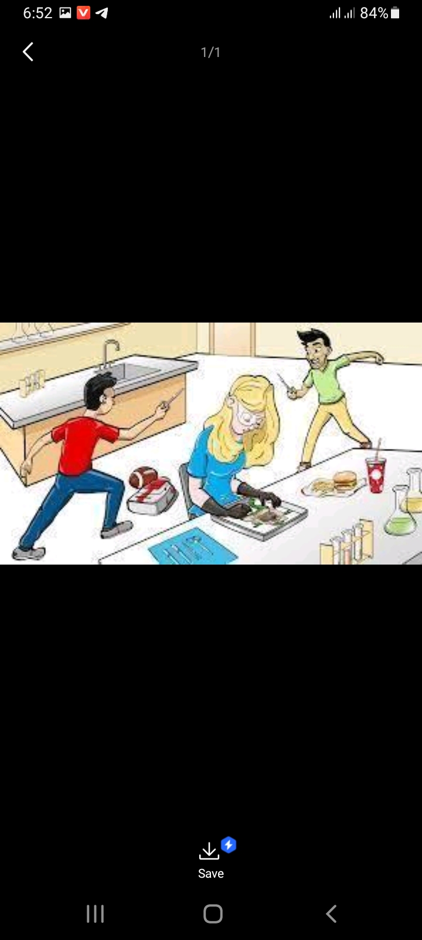

**TASK: Write a speech sensitizing students on the unsafe behaviors you have seen with dangers they may cause and state the guidelines you want them to follow when in the laboratory. (20marks)**

**QUESTION 3**

**Grace wanted to drink water but discovered that water had been kept in fridge for some time and had turned into solid form, so she had to wait for different time intervals for water to turn into liquid such that she can take it.**

**TASK:** As a student with the knowledge of chemistry you are acquired, advice Grace on how this water will be able to become a liquid such that she can take. In your advice; sketch a temperature-time graph and label features. Use your graph and particle theory of matter to explain the changes of state that took place. (**20marks)**



**QUESTION 4Mr. Masese went to the garden with his young son William to plant beans since it was a wet season. While in the garden he got emergence phone call and was needed urgently. On a rush to get home, he told William to carry his hoe back. Unfortunately, he forgot to carry it and they were to go back to the garden after 2days. On reaching there the hoe had brown coating and they did not know what had happened, William got scared and apologized to the father for the mistake he did but he told him to always be careful and that he was going to find a way out so that they could regain the hoe.**

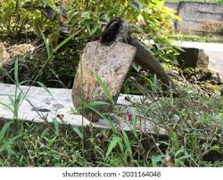

**TASK: As a chemistry student, write an article advising Mr. Masese about what happened suggesting the possible causes, how it can be controlled and prevented. (20marks)**

**Success comes to those who work hard and determined.**